How to Edit the CTE Posters for Printing:
_{Editing in a Web Browser:}
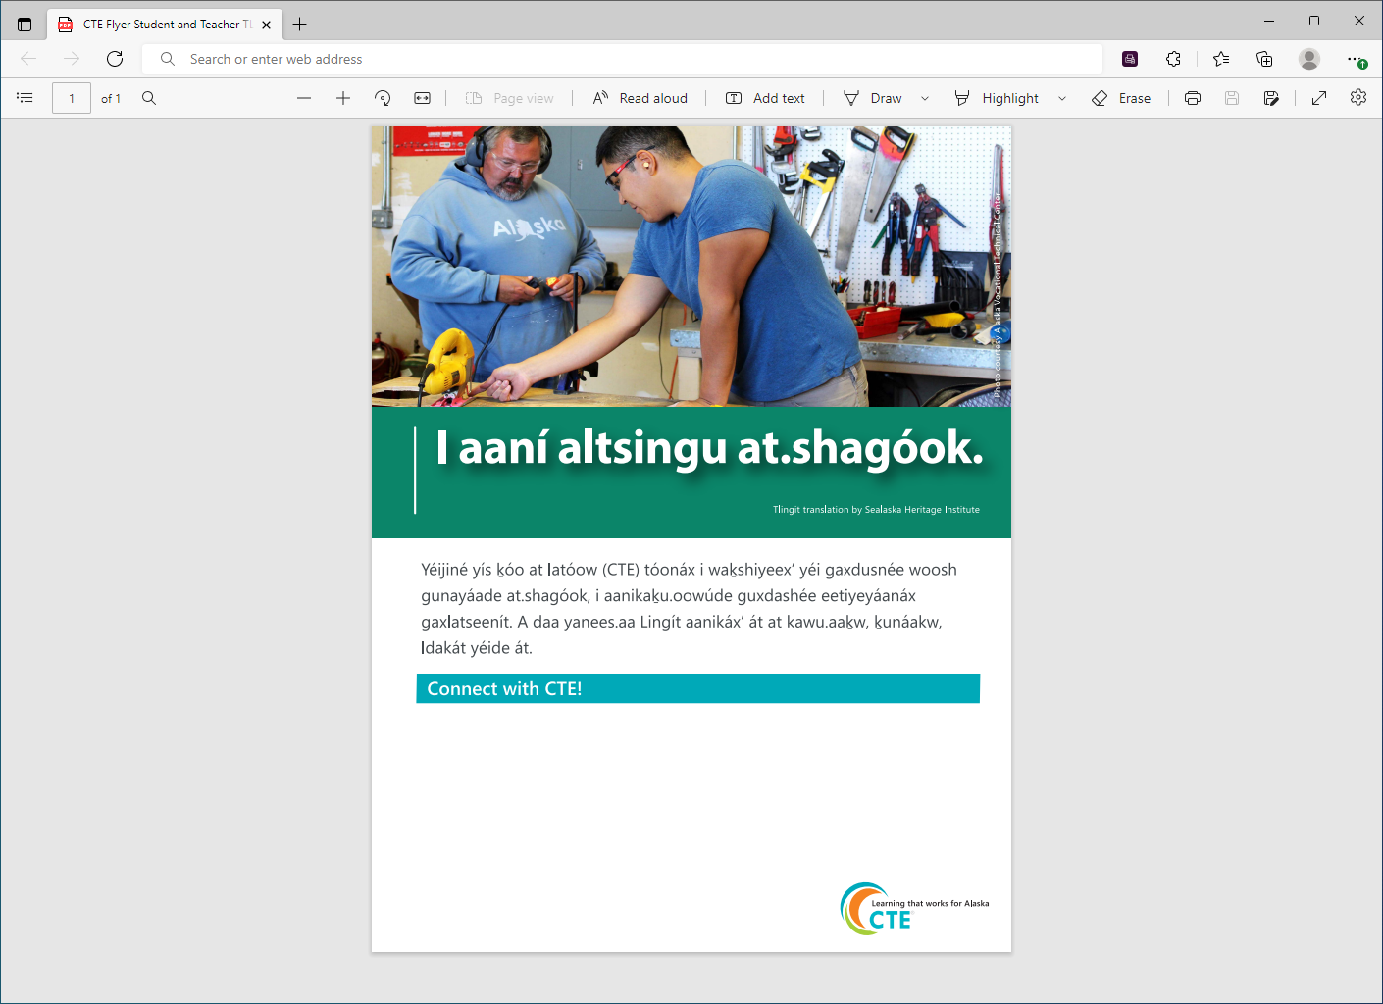
These posters are designed so that you can enter your own information at the bottom and print them on-site. You can then hang them in your school or in your community to promote CTE.
- Event Details (Career Fair, CTE certification awards, etc.)
- Counselor Contact Information
- Thank You (Elder or local business who helped with CTE class, etc.)
Please only add text in this space

_{Editing in Adobe Acrobat:}
